

New Aviation Activity Approval

Requirements Definition Document
V1.0

Revision & Sign-off Sheet
Change Record
Date | Author | Version | Change Reference
14-04-2019 | Rizwan Ansari | 1.0

Document Properties
Item | Details
Document Title | New Aviation Activity Approval
Author | Rizwan Ansari
First Creation Date | 14-04-2019
Last Updated By | Rizwan Ansari
Last Updated Date | 14-04-2019

Business Approvals
Name | Version | Position | Signature & Date
Michelle Gonsalves | 1.0 | Chairman Executive Secretary

Table of Contents
Contents
1 Introduction 4
2 Form Fields 5
3 Documents (Attachments) required 12
4 Flowchart 13
4.1 Workflow Description 16
4.2 Statuses 18
4.3 Notifications 19
4.4 Workflow Stages for SAP Integration 20
4.5 Rules 21
4.6 Screens 22
4.6.1 New Aviation Activity Application Form 22
4.6.2 Customer Dashboard 22
4.6.3 Approver (Department) Dashboards 23
4.6.4 Fields/Buttons 25
5 Payment Gateway 27
6 SAP 27
6.1 Web Services for SAP 27
6.2 Rate Card 28
6.3 Payment Information, Invoice & Receipts in SAP 28
7 KPI & Reports 28
8 KIOSK 28
9 SMS Gateway Integration 29
10 QR Code Integration 29

Introduction
The New Aviation Activity Approval workflow is used to register a Government Entity along with giving approval for Aviation Activities.

Form Fields
The New Aviation Activity Approval Form that is filled by the Customer is shown below:
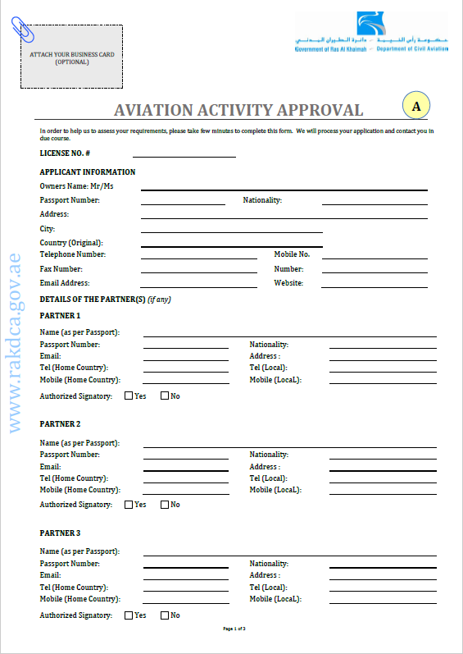
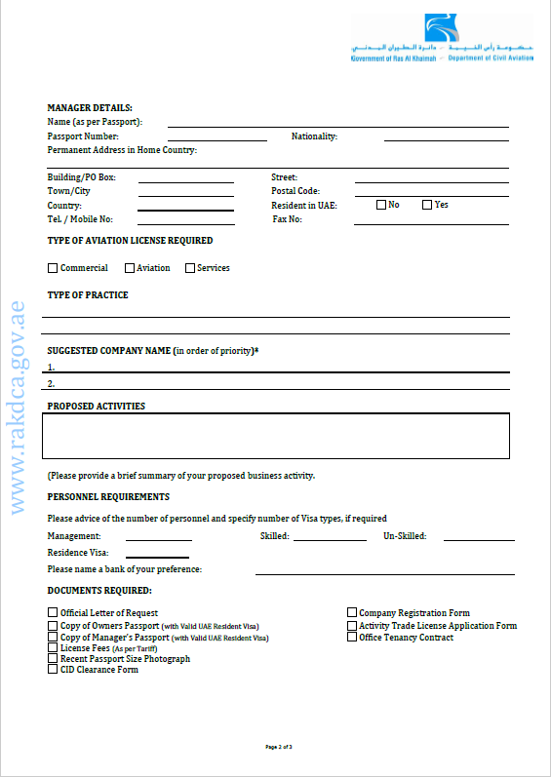
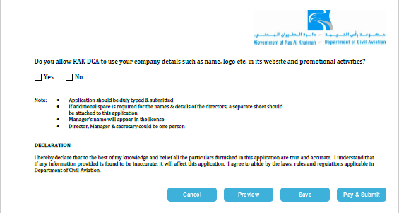
The table below gives a description of the fields:
Field Name | Data Type | Mandatory? | Remarks
License No. | Single Line Text | Yes | Auto generated
Company Name | Single Line Text | Yes | Auto-filled from logged in user’s detail. However; details can be changed by the user.
Owners Names Mr/Ms | Single Line Text | Yes | Auto-filled from logged in user’s detail. However; details can be changed by the user.
Emirates ID | Single Line Text | Yes | Auto-filled from logged in user’s detail. However; details can be changed by the user.
Passport Number | Single Line Text | Yes | Auto-filled from logged in user’s detail. However; details can be changed by the user.
Nationality | Single Line Text | Yes | Auto-filled from logged in user’s detail. However; details can be changed by the user.
Address | Multiple Line Text | Yes | Auto-filled from logged in user’s detail. However; details can be changed by the user.
City | Single Line Text | Yes | Auto-filled from logged in user’s detail. However; details can be changed by the user.
Country (Origin) | Drop down | Yes | Auto-filled from logged in user’s detail. However; details can be changed by the user.
Telephone Number | Number | Yes | Auto-filled from logged in user’s detail. However; details can be changed by the user.
Mobile Number | Number | Yes | Auto-filled from logged in user’s detail. However; details can be changed by the user.
Fax Number | Number | No | Auto-filled from logged in user’s detail. However; details can be changed by the user.
Number | Number |  | Auto-filled from logged in user’s detail. However; details can be changed by the user.
Email Address | Single Line Text | Yes | Auto-filled from logged in user’s detail. However; details can be changed by the user.
Website | Single Line Text | No | Auto-filled from logged in user’s detail. However; details can be changed by the user.
Partner 1
Name (as per Passport) | Single Line Text | Yes
Passport Number | Single Line Text | Yes
Nationality | Single Line Text | Yes
Email | Single Line Text | Yes
Address | Multiple Line Text | Yes
Tel (Home Country) | Number | Yes
Tel (Local) | Number | Yes
Mobile (Home Country) | Number | Yes
Mobile (Local) | Number | Yes
Authorized Signatory | Yes/No (Check Box) | Yes
Partner 2
Name (as per Passport) | Single Line Text | Yes
Passport Number | Single Line Text | Yes
Nationality | Single Line Text | Yes
Email | Single Line Text | Yes
Address | Multiple Line Text | Yes
Tel (Home Country) | Number | Yes
Tel (Local) | Number | Yes
Mobile (Home Country) | Number | Yes
Mobile (Local) | Number | Yes
Authorized Signatory | Yes/No (Check Box) | Yes
Partner 3
Name (as per Passport) | Single Line Text | Yes
Passport Number | Single Line Text | Yes
Nationality | Single Line Text | Yes
Email | Single Line Text | Yes
Address | Multiple Line Text | Yes
Tel (Home Country) | Number | Yes
Tel (Local) | Number | Yes
Mobile (Home Country) | Number | Yes
Mobile (Local) | Number | Yes
Authorized Signatory | Yes/No (Check Box) | Yes
Manager Details
Name (as per Passport) | Single Line Text | Yes
Passport Number | Single Line Text | Yes
Nationality | Single Line Text | Yes
Permanent Address in Home Country | Multiple Line Text | Yes
Building/PO Box | Single Line Text | Yes
Street | Single Line Text | Yes
Town/City | Single Line Text | Yes
Postal Code | Number | Yes
Country | Drop down | Yes
Resident in UAE | Yes/No (Check Box) | Yes
Tel. / Mobile No. | Number | Yes
Fax No. | Number
Company Representative Details
Same as Manager | Yes/No (Check Box)
Name (as per Passport) | Single Line Text | Yes
Passport Number | Single Line Text | Yes
Nationality | Single Line Text | Yes
Permanent Address in Home Country | Multiple Line Text | Yes
Building/PO Box | Single Line Text | Yes
Street | Single Line Text | Yes
Town/City | Single Line Text | Yes
Postal Code | Number | Yes
Country | Drop down | Yes
Resident in UAE | Yes/No (Check Box) | Yes
Tel. / Mobile No. | Number | Yes
Fax No. | Number
Type of Approval Required | Multi Select | Yes | Commercial / Aviation / Services
Proposed Activities (Please provide a brief summary of your proposed business activity) | Multiple Line Text | Yes
Management | Number | Yes
Skilled | Number | Yes
Un-Skilled | Number | Yes
Resident Visa | Single Line Text | Yes
Please name a bank of your preference | Single Line Text | Yes
Official Letter of Request |  | Yes
Company Registration Form |  | Yes
Copy of Owners Passport (with Valid UAE Resident Visa) |  | Yes
Activity Trade License Application Form |  | Yes
Copy of Manager’s Passport (with Valid UAE Resident Visa) |  | Yes
Office Tenancy Contract |  | Yes
License Fee (As per Tariff) |  | Yes
Recent Passport Size Photograph |  | Yes
CID Clearance Form |  | Yes
Do you allow RAK DCA to use your company details such as name, logo etc. in its website and promotional activities | Yes/No (Check Box) | Yes

Documents (Attachments) required
User will have to attach following documents:
- Company Registration Form – This will be auto generated by the system based on submitted information.
- Copy of Owners Passport (with Valid UAE Resident Visa)
- Activity Trade License Application Form
- Copy of Manager’s Passport (with Valid UAE Resident Visa)
- Office Tenancy Contract
- Recent Passport Size Photograph
- CID Clearance Form - Will be auto generated based on information submitted by Customer

Flowchart
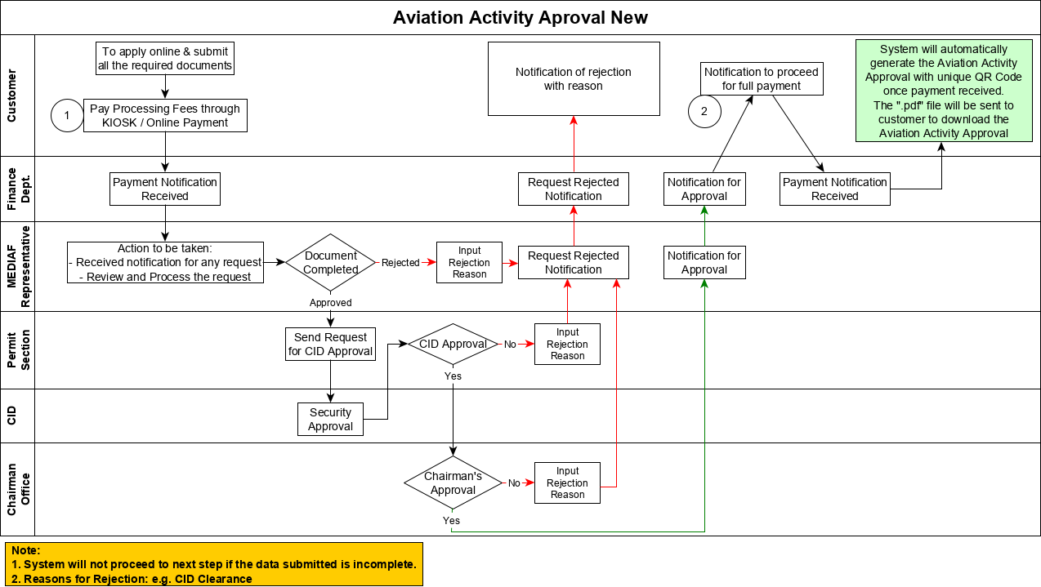

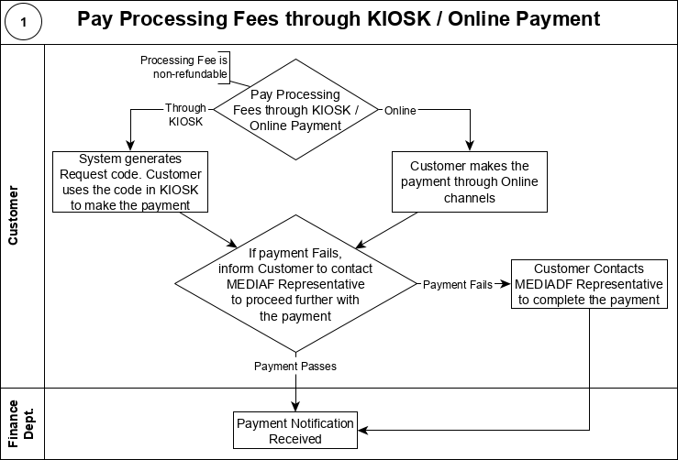
The Processing Fees is non-refundable. The Processing Fees for the New Aviation Activity Approval will include the Processing Fees for:
- Company Registration
- Representative Card
A bifurcation of the fees will be provided to the customer.
The payment information is synched into the SAP system.

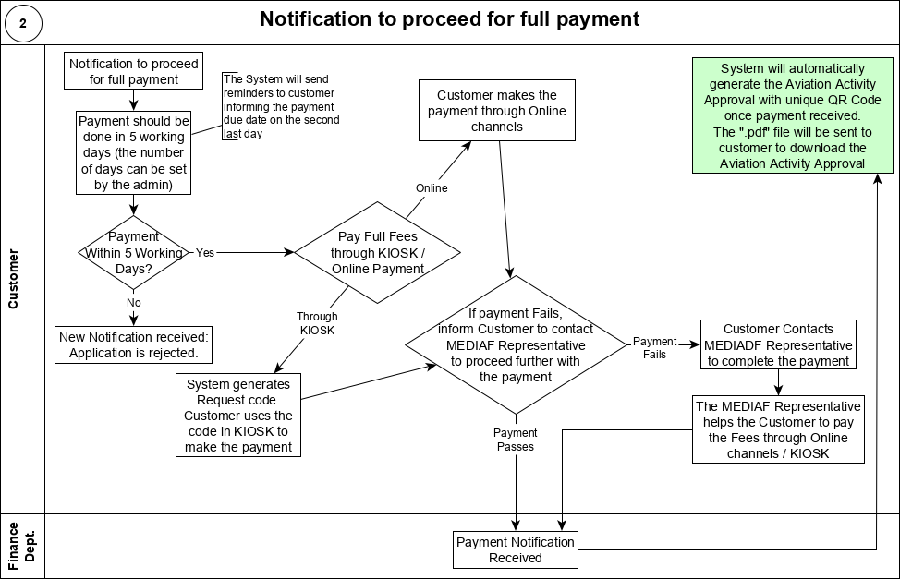
After approval by the Chairman Office, the Customer is required to pay the full Fees.
The payment collected will be for: Activity License + Registration Process + Representative Card
The tariff can be modified by MEDIAF Representative but will have to provide a justification for change
The payment should be done within 5 working days. The number of days required to pay for this workflow is controlled by the system admin.
The system sends reminders (on the first day and the second last day) to the customer for paying the full fees within the time period.
If the payment is not made within the time period, then the request is rejected and the customer is notified. The Customer can choose to re-submit the application by inputting / selecting the reason for rejection.
All Departments (Finance Department, MEDIAF Representative, Permit Section, and Chairman Office) are notified of the request rejection.
The payment information is synched into the SAP system.

Workflow Description
Sr. No. | Role | Action | Description
1 | Customer | Submits online form | The Customer can select to save the form as a draft and can also preview the filled form before submitting.  - If saved as draft, the Customer will receive a notification for successfully saving the draft.  - The customer has 5 days to submit the form otherwise the application is deleted. The number of days is managed by the Admin user.
2 | Customer | Pays the Processing Fees | Note: The Processing fee will include the Processing Fees for Company Registration + Representative Card + Employee ID. A bifurcation of the fees will be provided to the customer.  Note: The Processing Fee is non-refundable.  If KIOSK is chosen, Customer goes to a KIOSK and makes the payment using the service request number.  If Online Payment is chosen, then the Payment Gateway’s website is displayed and the customer makes the payment there.  Note: For any reason, the payment does not go through; the Customer can contact the MEDIAF Representative to complete the payment.
2.1 | Departments  (Finance  Department,  MEDIAF Representative,  Permit Section, and Chairman Office) | Receive Notification of the new request | After successfully paying the Processing Fee, the Departments (Finance Department, MEDIAF Representative, Permit Section, and Chairman Office) are notified of the request and the payment of the processing fees.
3 | MEDIAF Representative | Checks and Reviews the Request | If the Documents or the Form is deemed not satisfactory by the MEDIAF Representative, the MEDIAF Representative can reject the request.  - The MEDIAF Representative enters the reason for rejection and this is notified to the Customer.  - All Departments (Finance Department, MEDIAF Representative, Permit Section, and Chairman Office) are notified of the request rejection.  If the MEDIAF Representative approves the request, the request is then sent to the Permit Section. However; before approving, MEDIAF must translate the request into Arabic for submission to CID for approval.  - Permit Section is notified of the request.  MEDIAF representative can also request for change in information by Customer. In this case, MEDIAF must enter the remarks before sending the form back to customer for modification.
4 | Permit Section | Creates the ‘CID Security Approval’ task | If the request is approved by the MEDIAF Representative, then the Permit Section gets the notification to submit the request to CID for security approval. The request (Form and Documents) are sent to the CID via separate system and their approval is sought.
5 | CID | Approve or Reject the request | The CID can approve or reject the request.
5.1 | Permit Section | Inputs the CID’s Decision | If the CID rejects the request, then the Permit Section enters the rejection reason (For example: rejected by CID) and the customer is notified.  - All Departments (Finance Department, MEDIAF Representative, Permit Section, and Chairman Office) are notified of the request rejection.  If the CID approves the request, then the Permit Section updates the status of the request (For example: CID Approved) and forwards the request to the Chairman Office.  - Chairman Office is notified to submit the approval.
6 | Chairman Office | Approve or Reject the request | If the request is approved by CID, then the request comes to the Chairman Office. The Chairman Office can either approve or reject the request.  - If the Chairman Office rejects the request, then the Chairman Office enters the reason for rejection and this is notified to the customer.  - All Departments (Finance Department, MEDIAF Representative, Permit Section, and Chairman Office) are notified of the request rejection.  - If the Chairman Office approves the request, then the status of the request is changed (for example: Approved by Chairman Office) and the Customer is notified to pay the Full Amount
7 | Customer | Pay Full Fees | After approval by the Chairman Office, the Customer is notified to pay the full Fees.  - The payment should be done within 5 working days. The number of days required to pay is controlled by the system admin.  - The system sends reminders (on the first day and the second last day) to the customer for paying the full fees within the time period.  - If the payment is not made within the time period, then the request is rejected and the customer is notified.  - All Departments (Finance Department, MEDIAF Representative, Permit Section, and Chairman Office) are notified of the request rejection.  - Note: For any reason, the payment does not go through; the Customer can contact the MEDIAF Representative to complete the payment.
7.1 | Departments  (Finance  Department,  MEDIAF Representative,  and Chairman Office) | Receive Notification of the Full Fees Payment Action | - If the Full Fees is not paid within the time-period, then all Departments will get notified of the request rejection due to non-payment of full fees within time-period.  - If the Full Fees is paid, then Finance, Mediaf, and Chairman Office, will be notified of the payment.
8 | System | Generate Aviation Activity Approval with unique QR Code | If the Customer successfully pays the full fees, then the System will automatically generate the Aviation Activity Approval with unique QR Code once payment received. The ".pdf" file will be sent to customer to download the  Aviation Activity Approval  All Departments (Finance Department, MEDIAF Representative, and Chairman Office) are notified of the request approval and the status of the request.

Statuses
The statuses for Request in the workflow are: Draft, New, Pending Approval, Need More Info, Rejected, Payment Pending, and Approved.
The status of the Request can be seen by the Customer and the Departments (Finance Department, MEDIAF Representative, Permit Section, and Chairman Office)
The Statuses of the request at the various steps of the workflow is shown below:
Sr. No. | Step | Status | Assigned to
1 | Customer drafts the Application Request | Draft | Customer
1.1 | Customer creates Application Request | Payment Pending | Customer
1.2 | Payment Fails for Processing Fees | Payment Fail | Customer
1.3 | Customer pays Processing Fees | New | MEDIAF Representative
2 | MEDIAF Representative approves the request | Pending Approval | Permit Section
2.1 | MEDIAF Representative rejects the request | Rejected
2.2 | MEDIAF Representative request for more information | Need More Info | Customer
3 | Permit Section sends Request to CID | Pending Approval | Permit Section/CID
3.1 | Permit Section enters CID Approval | Pending Approval | Chairman Office
3.2 | Permit Section enters CID Rejection | Rejected
4 | Chairman Office Approves Request | Payment Pending | Customer
4.1 | Chairman Office Rejects Request | Rejected
5 | Customer to Pay Full Fees | Payment Pending | Customer
5.1 | Customer Pays the Full Fees | Approved
5.2 | Payment for Full Fees fails | Payment Fail | Customer
5.3 | Customer does not pay Full Fees within time period | Rejected

Notifications
The Notifications for the request that are sent at the various steps of the workflow is shown below:
Sr. No. | Step | Description of Notification | Sent to
1 | Customer drafts the Application Request | Draft saved successfully notification (Customer can submit the draft within 5 days – the number of days is managed by the Admin user) | Customer
1.1 | Customer creates Application Request | Request submitted successfully | Customer
1.2 | Payment of Processing Fees Fails | Payment Failed notification | Customer
1.3 | Customer pays Processing Fees | New Request generated and Processing Fees Received | Departments (Finance Dept., MEDIAF Representative)
2 | MEDIAF Representative approves the request | Request Approved by MEDIAF Representative | Permit Section
2.1 | MEDIAF Representative rejects the request | Application is rejected. | Customer
3 | Permit Section sends Request to CID | - | -
3.1 | Permit Section enters CID Approval | Request Approved by CID | Customer, Mediaf
3.2 | Permit Section enters CID Rejection | Application is rejected. | Customer, Mediaf, Chairman, Finance
4 | Chairman Office Approves Request | Notification to pay Full Fees | Customer
4.1 | Chairman Office Rejects Request | Request Rejected by Chairman Office | Mediaf
4.1 | Chairman Office Rejects Request | Application is rejected. | Customer
5 | Customer to Pay Full Fees | - | -
5.1 | Customer Pays the Full Fees | Request completed | Mediaf, Chairman Office, Finance
5.1 | Customer Pays the Full Fees | System will automatically generate the Aviation Activity  Approval with unique QR Code once payment received.  Aviation Activity Approval will be sent to the customer as PDF attachment to the email notification. Customer can also download the attachment using the link in the email notification. | Customer
5.2 | Customer does not pay Full Fees | Request Rejected - with the reason | Mediaf, Chairman Office, Finance
5.2 | Customer does not pay Full Fees | Application is rejected. | Customer
5.3 | Payment for Full Fees fails | Notify Customer of the payment failed status | Customer

Workflow Stages for SAP Integration
Sr. No. | Step | Description of Notification
1 | New Application | Fees for each service displayed on the form will be pulled from SAP system.
2 | Submit Application with Processing Fees | Payment details for processing fees is sent to SAP
3 | Submit Full Payment | Payment details for full fees are sent to SAP
4 | Invoice and Receipt | After payment is done invoice and receipts are generated.

Rules
- The Aviation Activity Approval will be shown as wizard with Previous and Next screen with each form on each screen. The wizard screens will be Aviation Activity Approval, Company Registration, Representative Card and CID Introduction form in each screen. The entire request will be submitted as a single request with single workflow
  - If company is already registered, or when entering information, same information is present on the next screen, those information will get auto-populated.
  - There can be multiple representative card by the company. However; during activity approval, only 1 will be issued. Later company can apply for more if needed
  - CID letter (not introduction letter) will be auto generated
- Payment will be collected for: Activity License + Registration Process + Representative Card
- The tariff will be shown on screen based on the selected service type
  - The tariff can be modified by MEDIAF Department but will have to provide a justification for change
- Validity of a Activity license: 1 year, or 2 year, or 3 year
- The soft copy (i.e. .pdf file) that is sent to the Customer after successful completion of workflow will have Chairman signature’s scanned copy and Seal
  - Aviation Activity Approval, Representative Card, and Company Registration will be sent as a soft copy on final payment by customer
- Activity license expiration notification will be sent a month prior to expiry to the following departments: Chairman Office, Mediaf, Finance, Customer
- Renewal and Expiration logic:
  - If Aviation Activity is expired and not renewed within grace period, the visa will be cancelled automatically after necessary reminders.
  - Notification of renewal goes to the Customer a month prior to expiration. Notification also goes to Chairman Office, Mediaf.
  - There will be 3 months of grace period after expiry.
    - If license is not renewed after the 3 months grace, the following will be cancelled:
      - Aviation activity
      - Company registration
      - Representative Card
      - Visas
  - Penalty
    - Penalty will be applied each month for a period of 3 months from the date of Aviation Activity Approval expiry. After 3 months, approval will be cancelled.
    - 100 AED per month is charged currently
    - Also, notify customer in reminder that the approval will be automatically cancelled if not renewed

Screens

New Aviation Activity Application Form
The Customer fills the online form to apply for a New Aviation Activity Approval. The form and its fields are described in the Form Fields section in this document.
At the bottom of the Form are four buttons to:
- Cancel the request
- Preview the request
  - This will open the filled form in a new window. This helps the Customer to check the information before submitting the request.
- Save the request
  - This will save the request as a “Draft”. The “Draft” can be kept for a maximum of 5 days (This time-period is decided by the Admin user). The “Draft” is deleted after this time-period. The Customer will receive notifications to submit the request during the draft time-period.
- Pay & Submit – This button will open the payment options page to pay the processing fee and will also submit the application.

Customer Dashboard
The Customer Dashboard shows all the applications and requests that the Customer has raised in the SharePoint System. The grid on the Dashboard will show the statuses of each of the requests.
A sample Dashboard (with dummy data) is shown below:
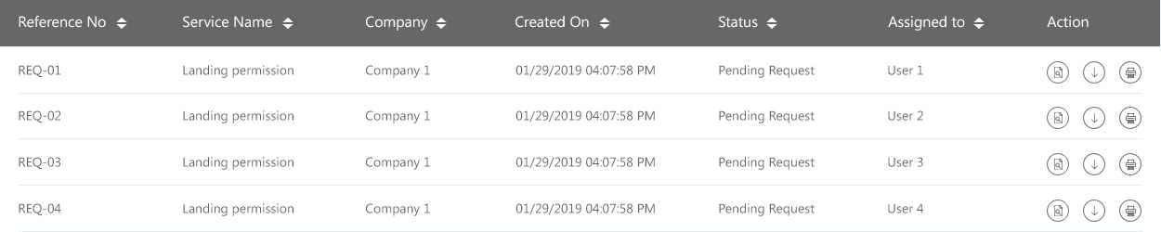

Print the Request
View the Request
Download the Request and associated files

Suppose, that an application is saved as a draft or requires input from the Customer, the Customer can open the pending request (by clicking the ‘View’ option for that request) to proceed further with the request.

Approver (Department) Dashboards
Each department will have individual dashboards that will show all the requests that are awaiting their action.
For example, the Permit Section will be shown the request on its Dashboard when the DCA Service Approves the request. The Permit Section then opens the request and is shown the option to create the task for the CID and Enter the CID’s approval/rejection.
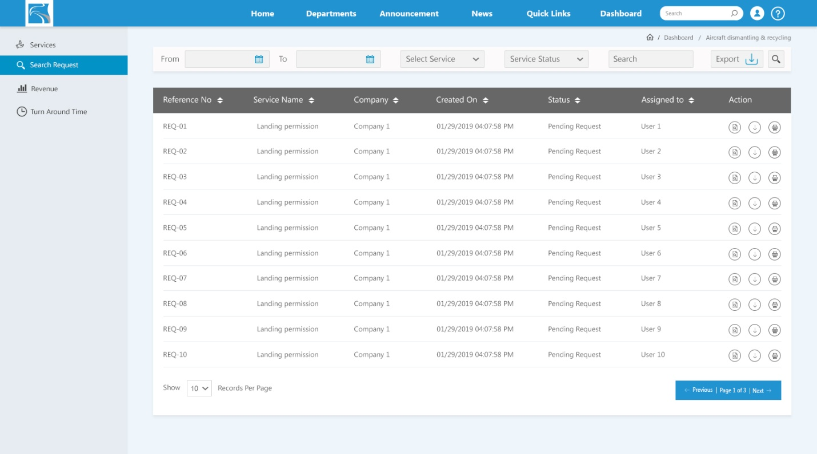
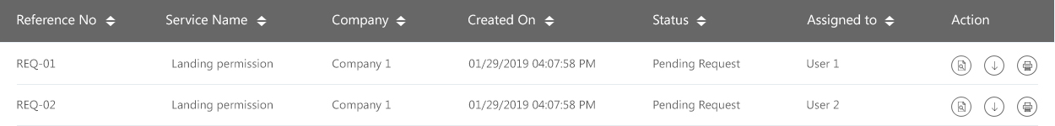
View the Request
Print the Request
Download the Request and associated files

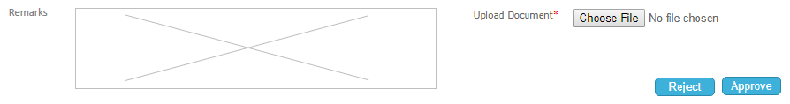
In another example, if an Approver has the ability to Request for more Information/Documents, then for that request, the Approver is shown the option to Request for more information.
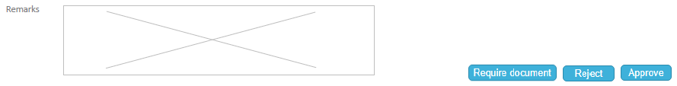
The below dashboard depicts the department KPIs and reports for each service for that department. User can click on particular service to view more details about that service.
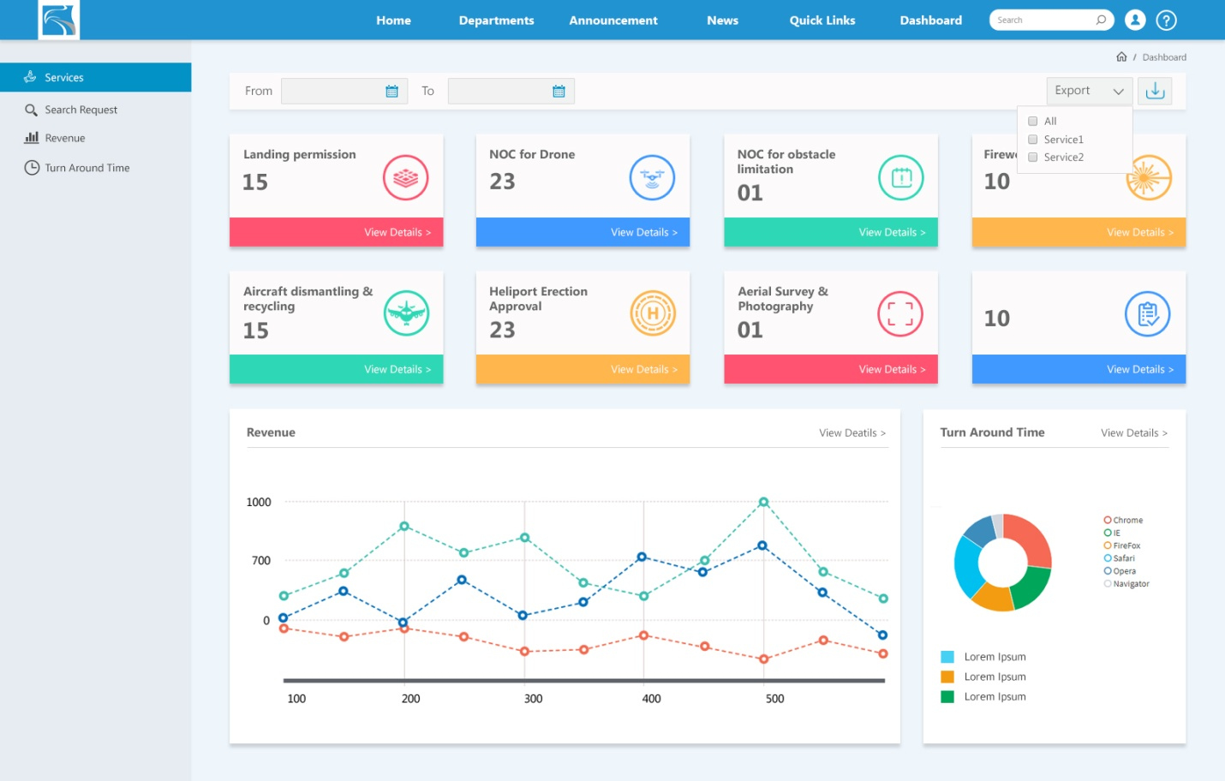
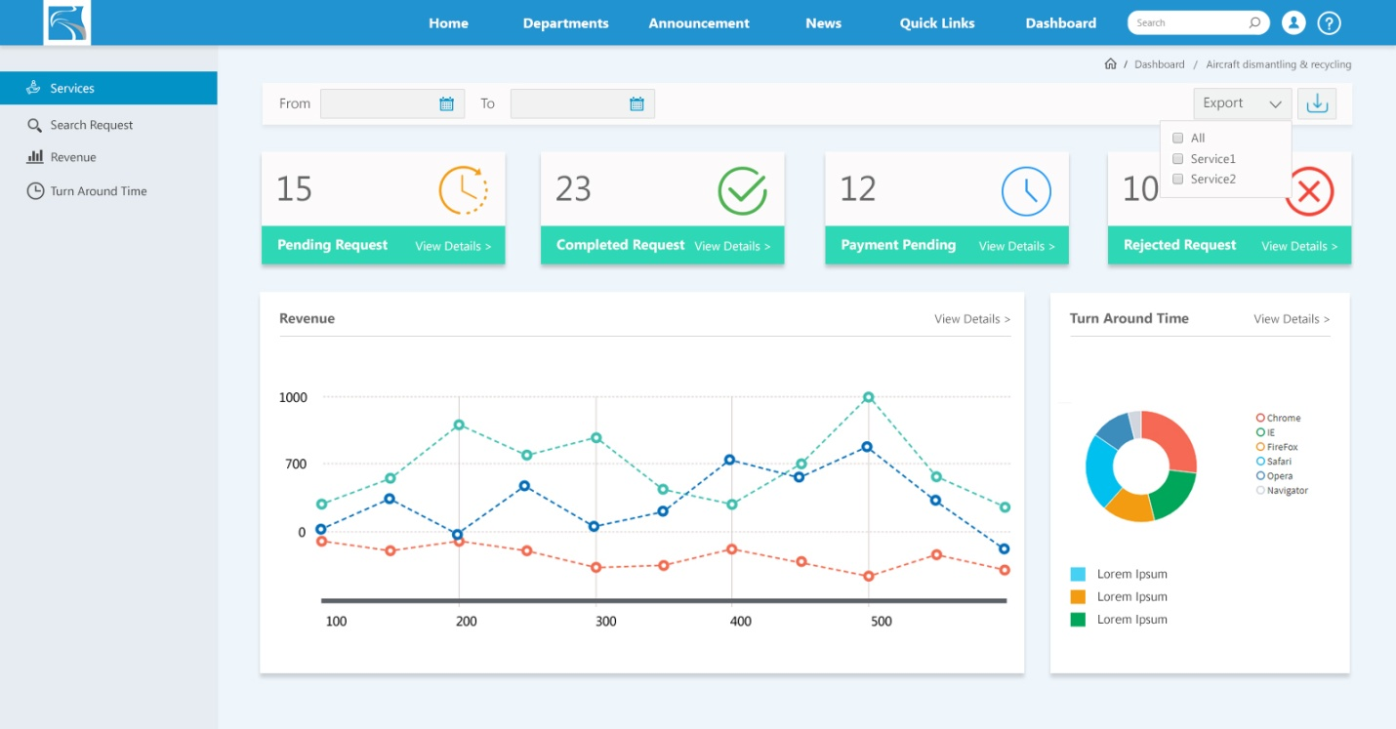

Fields/Buttons
User role | Screen / Page | Field / Button | Description
Customer | Application Form | Cancel | To cancel the request
 |  | Preview | This will open the filled form in a new window. This helps the Customer to check the information before submitting the request
 |  | Save | This will save the request as a “Draft”. The “Draft” can be kept for a maximum of 5 days (This time-period is decided by the Admin user). The “Draft” is deleted after this time-period. The Customer will receive notifications to submit the request during the draft time-period
 |  | Pay & Submit | This button will open the payment options page to pay the processing fee and will also submit the application
 |  | Retry Payment | If the processing fee is not successfully paid for the first time, then the Repay button appears that helps the customer to try to pay the processing fee again
 | Dashboard / View Request Page | Pay Full Fees | This button will open the payment options page to pay the Full Fees
 |  | Retry Full Fees | If the full fee is not successfully paid for the first time, then the ‘Repay Full Fess’ button appears that helps the customer to try to pay the processing fee again
 |  | Download Service Request | Clicking this button will download the requested service’s .pdf file
MEDIAF Representative | Dashboard | View | To open the request
 |  | Download | Download the application and associated files
 |  | Print | To print the request
 | View Request Page | Approve | To approve the request and forward the request as per the workflow to the next user/action
 |  | Upload Attachments | Mediaf will be able to upload attachment if needed
 |  | Fields to translate in other language | Arabic fields will be shown to translate the request in Arabic for CID submission.
 |  | Reject / Comments | To reject the request and forward the request as per the workflow to the next user/action. The user has to enter the rejection reason in the ‘Comments’ box
Permit Section | Dashboard | View | To open the request
 |  | Download | Download the application and associated files
 |  | Print | To print the request
 | View Request Page | For CID Approval | To create task for CID approval
 |  | CID Approve | To approve the request and forward the request as per the workflow to the next user/action
 |  | CID Reject / Comments | To reject the request and forward the request as per the workflow to the next user/action. The user has to enter the rejection reason in the ‘Comments’ box
Chairman Office | Dashboard | View | To open the request
 |  | Download | Download the application and associated files
 |  | Print | To print the request
 | View Request Page | Approve | To approve the request and forward the request as per the workflow to the next user/action
 |  | Reject / Comments | To reject the request and forward the request as per the workflow to the next user/action. The user has to enter the rejection reason in the ‘Comments’ box

Payment Gateway
All payment gateway related information and integration steps will be provided by EGA which will be implemented in the SharePoint system.

SAP
The SharePoint System will require integration with SAP system to push the payment information to SAP, get the fees for each service and activity, generate invoices and receipts.

Web Services for SAP
EGA will provide the required web services for integration with SAP modules (For example, FICO & MM module). CADD Emirates will not be responsible to do any development in SAP system. The SharePoint system will only call necessary Web services endpoints to push information to SAP or fetch information from SAP system.

Rate Card
The SAP will have all the rates for each service and activity defined in the Material Management module of SAP.
The SharePoint system will keep nightly sync of these rates into SharePoint system.

Payment Information, Invoice & Receipts in SAP
The payment information for each request will be pushed to SAP to create the necessary entries against the customer account in SAP.
Once payment information is pushed, all Invoices and Receipts will be generated through SAP and then synched into the SharePoint System against their respective e-service request. The synch will be scheduled activity to be done once or twice a day.
The SAP data (Payment Information, Invoice, Receipt, and more) are synched to the SharePoint System
If for any reason, the SAP system is not accessible, then:
- The SAP data that is stored in the SharePoint System is used.
- If a customer makes a payment, then the Payment Information from the Customers is stored in the SharePoint System and then synched into the SAP system when the SAP system is available.
- If a Customer wants to download Invoice/Receipt and that data was not yet synched, then the SharePoint System will show a message “Service is down, come back later”.

KPI & Reports
- Number of new Activity License issued (monthly, quarterly, annually)
- Income generated from Activity License (monthly, quarterly, annually)
- Number of new Company Registration issued (monthly, quarterly, annually)
- Income generated from Company Registration (monthly, quarterly, annually)
- Number of new Representative Card ID issued (monthly, quarterly, annually)
- Income generated from Representative Card ID (monthly, quarterly, annually)
- Turnaround time for the request / service (monthly, quarterly, annually)
- Happiness survey for the request / service (monthly, quarterly, annually)

KIOSK
KIOSK integration will be provided by EGA. CADD Emirates will not be responsible for development in KIOSK system.
Basically two web-services will be developed that will help the communication between the KIOSK and SharePoint system. The broad steps would be:
- The system will generate a payment request code/ID/number for a payment request.
- The Customer will enter this number in the KIOSK.
- The first web-service will Validate the request number and if correct will show the user the details of the transaction (i.e., the amount and description)
- The Customer makes the payment through the KIOSK machine.
- The KIOSK will call the second web-service to update the SharePoint system with the payment details.

SMS Gateway Integration
- All customer notification will be sent by Email as well as on SMS.
- Internal department approvers will also receive SMS, subject to configuration by Admin.
- SMS Gateway end point and all required instructions will be provided by EGA.
- CADD Emirates will be responsible only for calling the respective end points.

QR Code Integration
- QR code will be implemented in all the E-Services.
- The final NOC / Permit / Approval will have unique QR code on it.
- Scanners will be implemented at all internal departments, External Departments (Polices, Immigration, Airport Operations, etc.)
- Scanning the QR code will open the request on the screen. The respective department can then take necessary action as needed.

